Documentation for batchRCLC_v2.py 5/21/21

To run this program place the following files together in your working directory

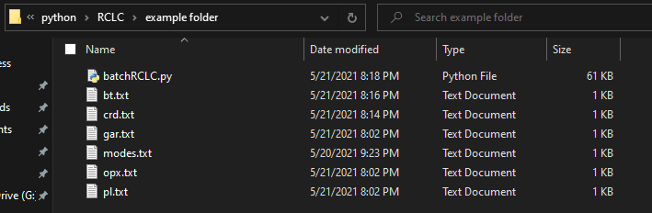

batchRCLC.py the python code

bt.txt the input biotite compositions (this file is optional. If you leave it out of the folder, biotite will not be considered in the calculation)

crd.txt the input cordierite compositions (this file is optional. If you leave it out of the folder, cordierite will not be considered in the calculation)

gar.txt the input garnet compositions. required

opx.txt the input orthopyroxene compositions. required

pl.txt the input plagioclase compositions. Required

modes.txt the input mineral modes to use for the calculations

The mineral composition files are tab-delimited text files. The program is not very smart, so the cation order must always be the same in each mineral composition file. Each new line is a new mineral composition to be considered in the calculation.

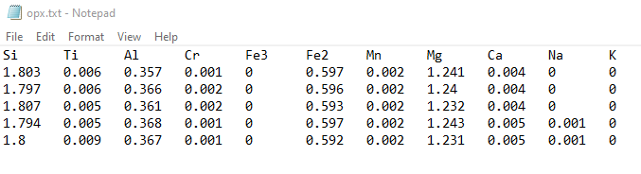

The modes file is a tab-delimited text file of the following format. If you are not using biotite or cordierite in the calculation, set their values to zero.

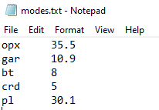

Run the program however you normally run python on your machine.

You will have the option of 4 models for estimating the Al content of the M site in opx to use for the calculations. You will be prompted to choose by entering an integer: 1,2,3, or 4.

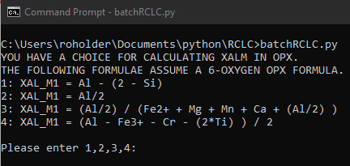

The program has two runmodes. If you entered the same number of mineral analyses into each input file, you will be prompted to choose which you want to use by entering “1” or “2”.

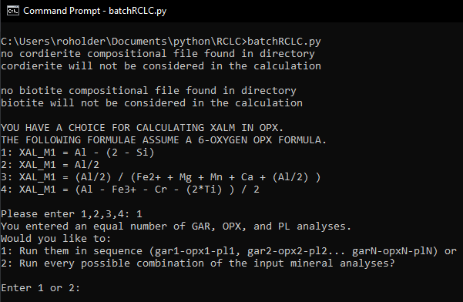

1. In this runmode, PT is calculated sequentially from input mineral compositions.
   1. For example, if 4 garnet, 4 orthopyroxene, and 4 plagioclase compositions were entered into the input file, the code would calculate PT for:
      1. gar1-opx1-pl1, gar2-opx2-pl2, gar3-opx3-pl3, gar4-opx4-pl4.
   2. For this mode to work, the same number of analyses is required for each input mineral. If you do not wish to exclude biotite or cordierite from the calculation, simply exclude their input files from your working directory.
2. In this runmode, PT is calculated for EVERY POSSIBLE combination of input mineral compositions.
   1. For example if 4 garnet, 3 orthopyroxene, and 2 plagioclase compositions were entered into the input file, the code would calculate PT for:
      1. gar1-opx1-pl1, gar1-opx1-pl2, gar1-opx2-pl1, gar1-opx2-pl2, gar1-opx3-pl1, gar1-opx3-pl2, gar2-opx1-pl1, gar2-opx1-pl2, gar2-opx2-pl1, gar2-opx2-pl2, gar1-opx3-pl1, gar2-opx3-pl2, gar3-opx1-pl1, gar3-opx1-pl2, gar3-opx2-pl1, gar3-opx2-pl2, gar3-opx3-pl1, gar1-opx3-pl2, gar4-opx1-pl1, gar4-opx1-pl2, gar4-opx2-pl1, gar4-opx2-pl2, gar4-opx3-pl1, gar4-opx3-pl2
   2. If an unequal number of compositions were input for each mineral, the code will run this mode by default.
   3. Be slightly wary of this mode, because the number of calculations increases exponentially with the number of analyses you wish to include. For example, if you have 6 analyses each of gar, opx, pl, crd, and bt, the total number of PT calculated will be 6^5 = 7776. This will take a few minutes to run!

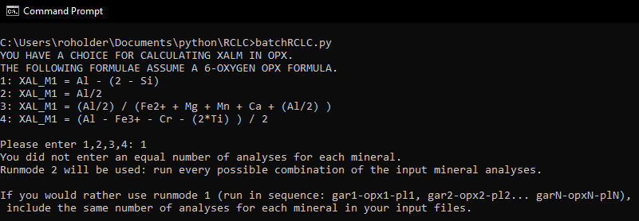

The output of your calculations will be written to a file called “outputfile.csv” in your working directory.

If you used runmode 1 the output will look like this (if not using biotite or cordierite, calculations involving them will return values of 0 for those equilibria):

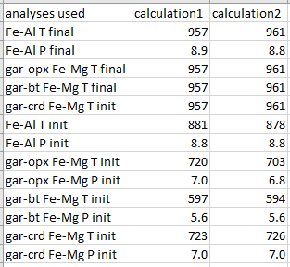

If you used runmode 2, the output will list the input mineral combinations corresponding to each calculation (if not using biotite or cordierite, calculations involving them will return values of 0 for those equilibria):

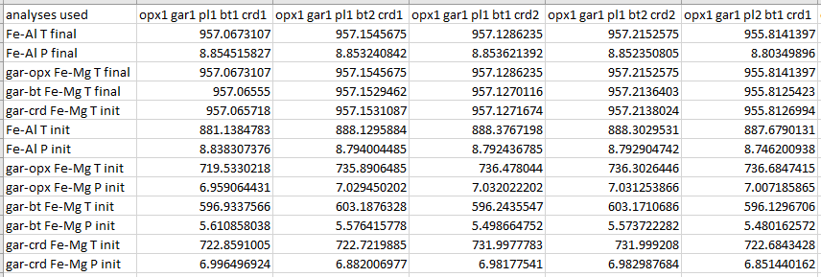

* The output rows are defined as:
  + The main Al-in-opx thermobarometry PT results after correction for Fe-Mg exchange:
    - Fe-Al T final: the converged temperature of Al-in-opx thermometry. It is called “Fe-Al” because the equilibrium used in the code is for the Fe mineral end-members.
    - Fe-Al P final: the converged pressure of gar-opx-pl-qtz barometry (GOPS). It is called “Fe-Al” because the equilibrium used in the code is for the Fe mineral end-members
* The Fe-Mg exchange temperatures after correction for Fe-Mg exchange (these should match Fe-Al T final if the code is running correctly
  + gar-opx Fe-Mg T final
  + gar-bt Fe-Mg T final
  + gar-crd Fe-Mg T final
* The initial PT from the intersection of Al-in-opx thermometer with GOPS barometer, before Fe-Mg exchange correction
  + Fe-Al T init
  + Fe-Al P init
* The initial PT from Fe-Mg exchange equilibria and GOPS barometer
  + gar-opx Fe-Mg T init gar-opx Fe-Mg P init
  + gar-bt Fe-Mg T init gar-bt Fe-Mg P init
  + gar-crd Fe-Mg T init gar-crd Fe-Mg P init